

NAME: DEEPANKAR SHARMA

COURSE: BCA-HALDWANI

UNIVERSITY ROLL NO: 20041299

STUDENT ID : 2091299

# Python Programming\_BCA2ndSemester

[TBC/PBC202\_Python](http://45.116.207.86/moodle/course/view.php?id=97" \o "PythonProgramming_BCA2ndSemester)

**INDEX**

|  |  |  |  |  |
| --- | --- | --- | --- | --- |
| Sr. No**.** | Assign. Date | Subm. Date | **Title** | Teacher’sRemark |
|  |  | **23 APRIL 2021** | **PYTHON PRACTICAL QUESTIONS 1** |  |
| **2.** |  | **30 APRIL 2021** | **PYTHON PRACTICAL QUESTIONS 2** |  |
| **3.** |  | **13 MAY 2021** | **PYTHON PRACTICAL QUESTIONS 3** |  |
| **4.** |  | **13 MAY 2021** | **PYTHON PRACTICAL QUESTIONS 4** |  |
| **5.** |  | **21 MAY 2021** | **PYTHON PRACTICAL QUESTIONS 5** |  |
| **6.** |  | **26 MAY 2021** | **PYTHON PRACTICAL QUESTIONS 6** |  |
| **7.** |  | **27 MAY 2021** | **PYTHON PRACTICAL QUESTIONS 7** |  |
| **8.** |  | **03 August 2021** | **PYTHON PRACTICAL QUESTIONS 8** |  |
| **9.** |  | **27 August 2021** | **PYTHON PRACTICAL QUESTIONS 9** |  |

**Python Programming Questions 1**

1. Write a python program to print your name, age, course, semester, address, university roll no.

# Deepankar Sharma

# student id : 20041299

# university roll no : 2092014

name = input('Enter your name :  ')

course = input('Enter your course :  ')

add = input('Enter your address :  ')

sem = int(input('Enter your semester :  '))

age = int(input('Enter your age :  '))

roll =int( input('Enter your roll no. :  '))

print('Name :',name)

print('Age :', age)

print('Course :',course)

print('semester :',sem)

print('University Roll Number :',roll)

print('Address :',add)

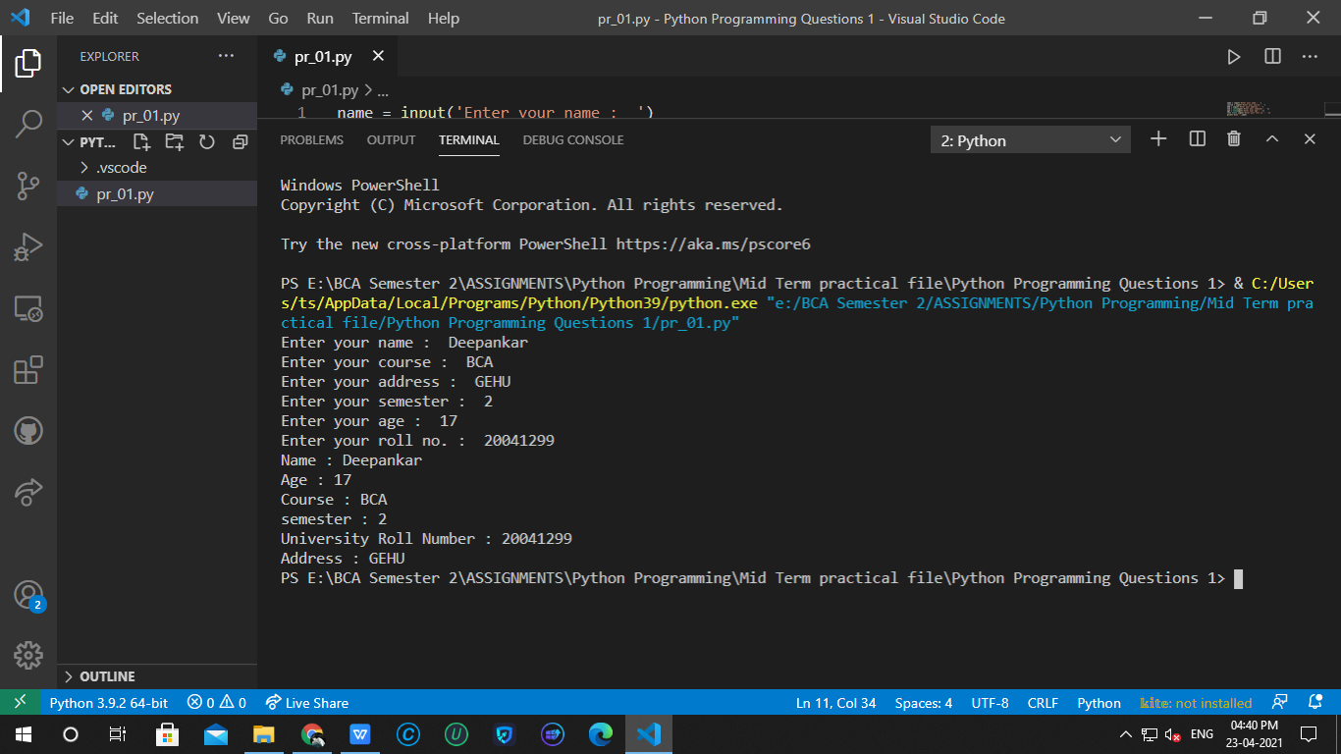

1. Write a python program to swap two numbers without using any third variable.

# Deepankar Sharma

# student id : 20041299

# university roll no : 2092014

a1 = int(input('Enter the first number :'))

a2 = int(input('Enter the second number :'))

a2=a1+a2

a1=a2-a1

a2=a2-a1

print('Swapped')

print(a1,a2)

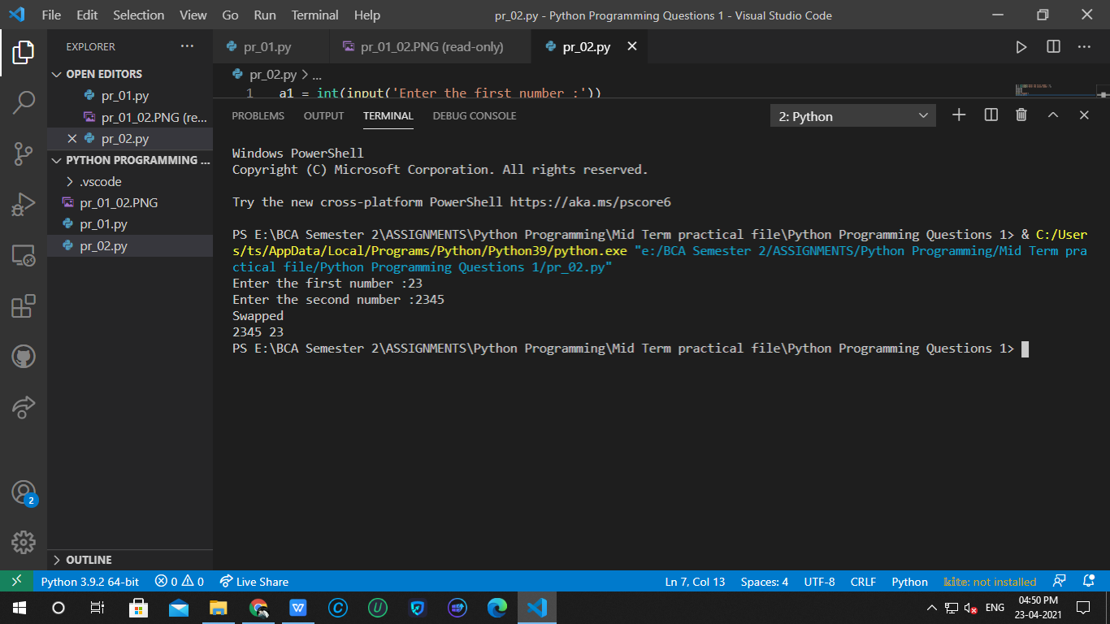

1. Write a python program to print the tables of 5 and 10.

# Deepankar Sharma

# student id : 20041299

# university roll no : 2092014

print('Table of 5 :')

print(f'5\*{1}={5\*1}')

print(f'5\*{2}={5\*2}')

print(f'5\*{3}={5\*3}')

print(f'5\*{4}={5\*4}')

print(f'5\*{5}={5\*5}')

print(f'5\*{6}={5\*6}')

print(f'5\*{7}={5\*7}')

print(f'5\*{8}={5\*8}')

print(f'5\*{9}={5\*9}')

print(f'5\*{10}={5\*10}')

print('Table of 10 :')

print(f'10\*{1}={10\*1}')

print(f'10\*{2}={10\*2}')

print(f'10\*{3}={10\*3}')

print(f'10\*{4}={10\*4}')

print(f'10\*{5}={10\*5}')

print(f'10\*{6}={10\*6}')

print(f'10\*{7}={10\*7}')

print(f'10\*{8}={10\*8}')

print(f'10\*{9}={10\*9}')

print(f'10\*{10}={10\*10}')

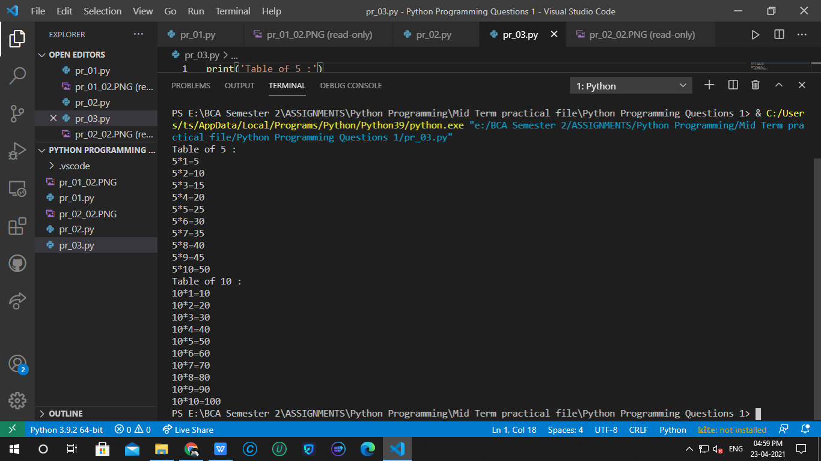

**Python Programming Questions 2**

1. Write a python program to print to print “hello students how are you” as “how are you hello students “ five times without using print statement 5 times.

str = 'Hello students how are you \n '

str1 = str.replace(str, '''how are you  Hello students\n''')

print(5\*str1)

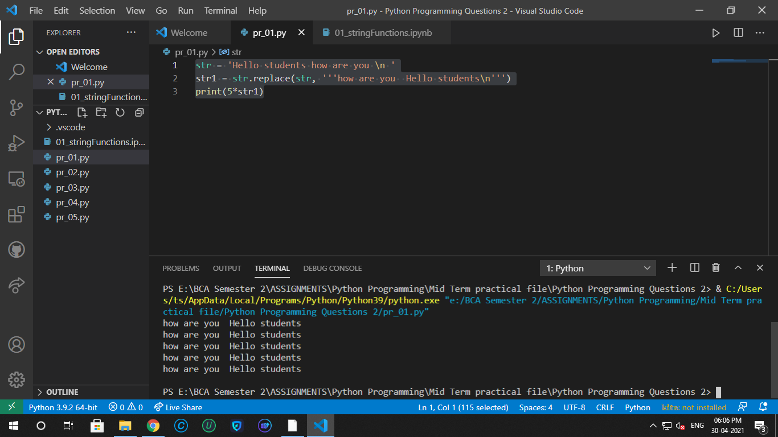

1. Assume any string which contains ‘second semester’ , replace it with ‘third semester’. Also print the position of third semester.

str = 'I am in second semester'

str = str.replace('second', 'third')

print(str)

# pos1=str.index('third')# returns value error -----> if index not found

# print('position is', pos1)

pos2=str.find('third')# doesn't return value error -----> if index not found

print('position is', pos2)

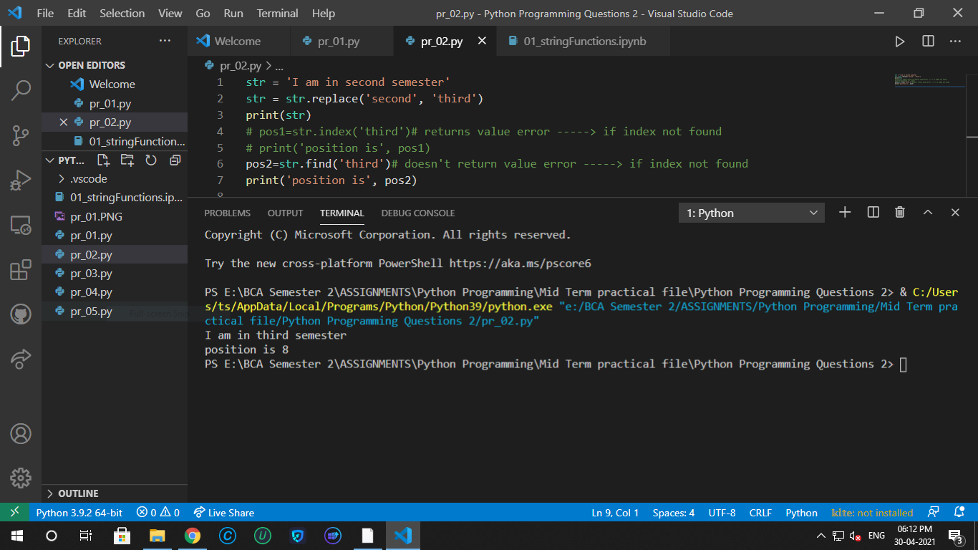

1. Take any string which contains more than two lines about you. Now count number of times ‘i’ occurs in the string.

str = '''Hello !!! My name is Deepankar Sharma.

         I am pursuing BCA as of now from Graphic Era Hill University .

         It is really cool..'''

cnt = str.count('i')

print(f'i occurs {cnt} times')

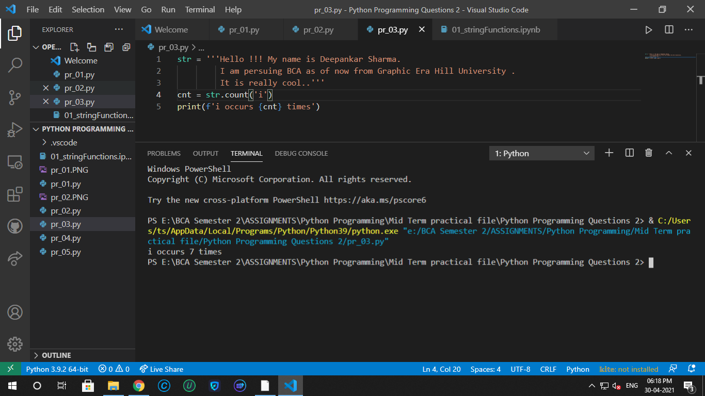

1. Consider any long string . Now replace the space between two words with the tab.

str = '''      Hello   !!!   My   name   is   Deepankar   Sharma.         '''

str = str.split()

print(' '.join(str))

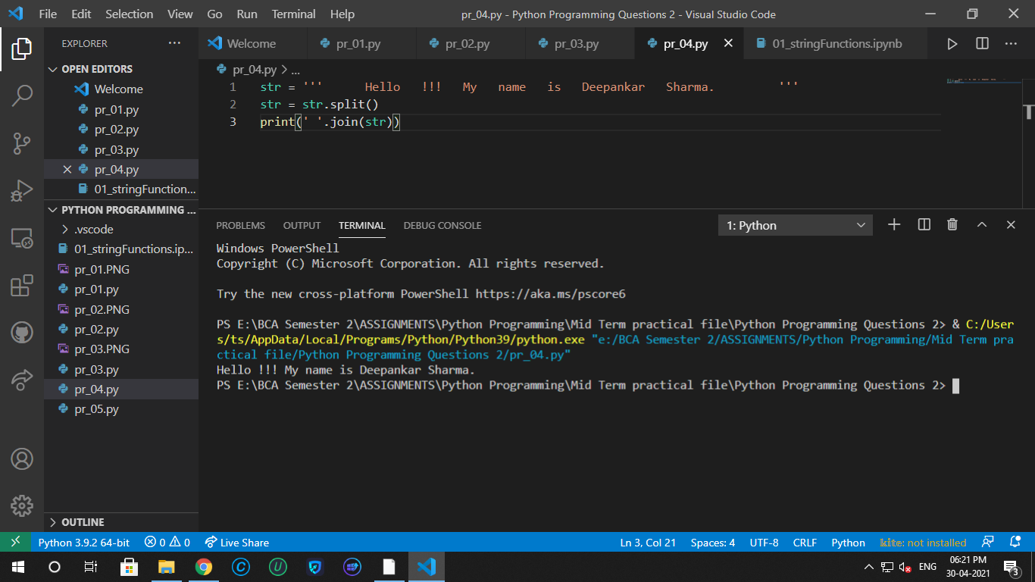

1. Write a python program which can identify and print output whether a given string is a website name or not.

str = input('Enter a website : ')

if '.com' in str:

    print('It is a website')

elif '.in' in str:

    print('It is a website')

else:

    print('It is not a website')

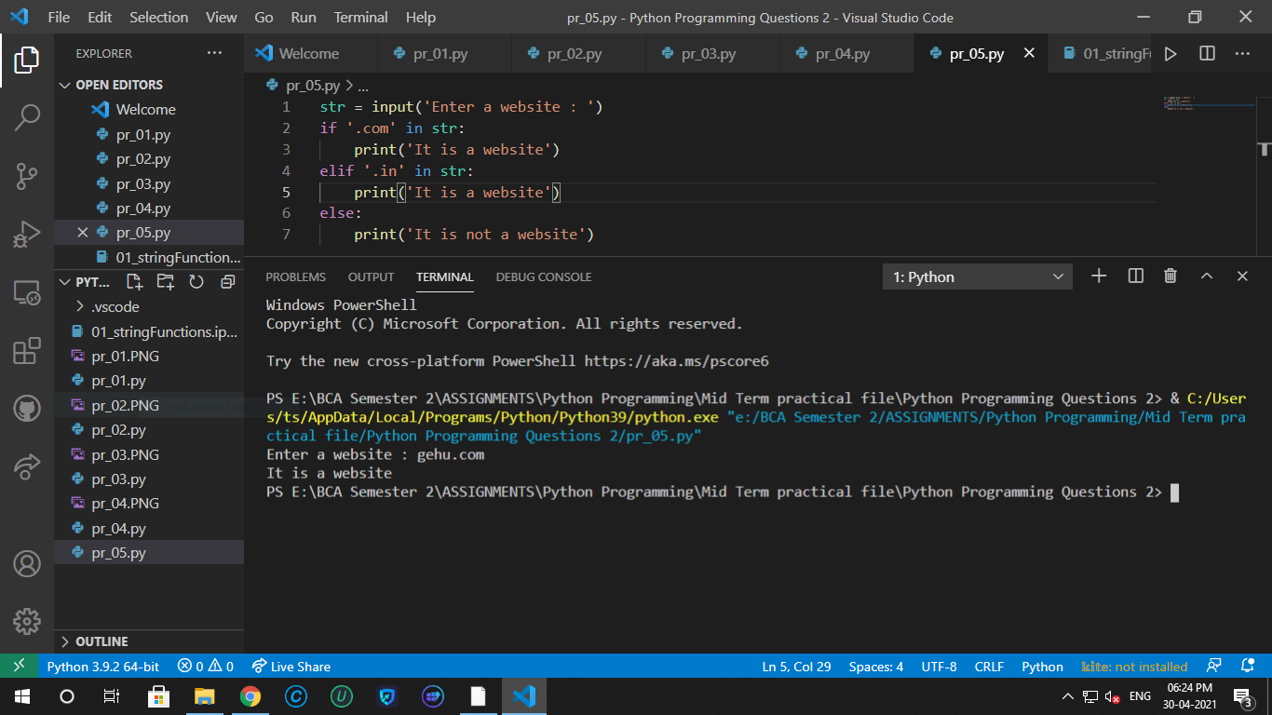

**Python Programming Questions 3**

1. Take any list and print it in following manner.
2. Print only last three elements.
3. Print all values except the first and last value.
4. Print only first three elements.

l1 = ['deepankar', 'ram', 'dean', 'sam', 'oliver', 'roy', 'mia', True, 1, 2 ,'barry', 'felicity']

# (a) # last three elements

print(l1[-3:])

# (b) # all elements except first and last

print(l1[1:-1])

# (c) # first three elements

print(l1[:3])

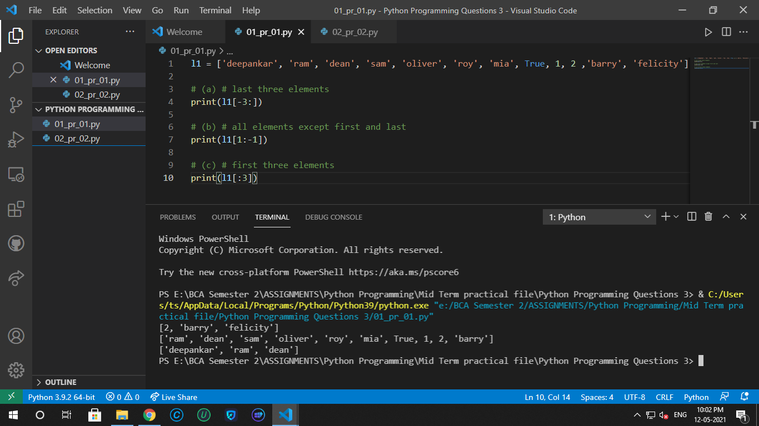

1. In a python program, consider any list containing integer, decimal and string values . Now delete all decimal values using any list delete functions and then add three character values in it.

l1 = ['deepankar', 56.45, 'oliver', 'roy', 'mia', 1, 2 ,'barry', 'felicity', False]

l1.remove(56.45)

l1.append('A')

l1.insert(4,'g')

l1.insert(7,'O')

print(l1)

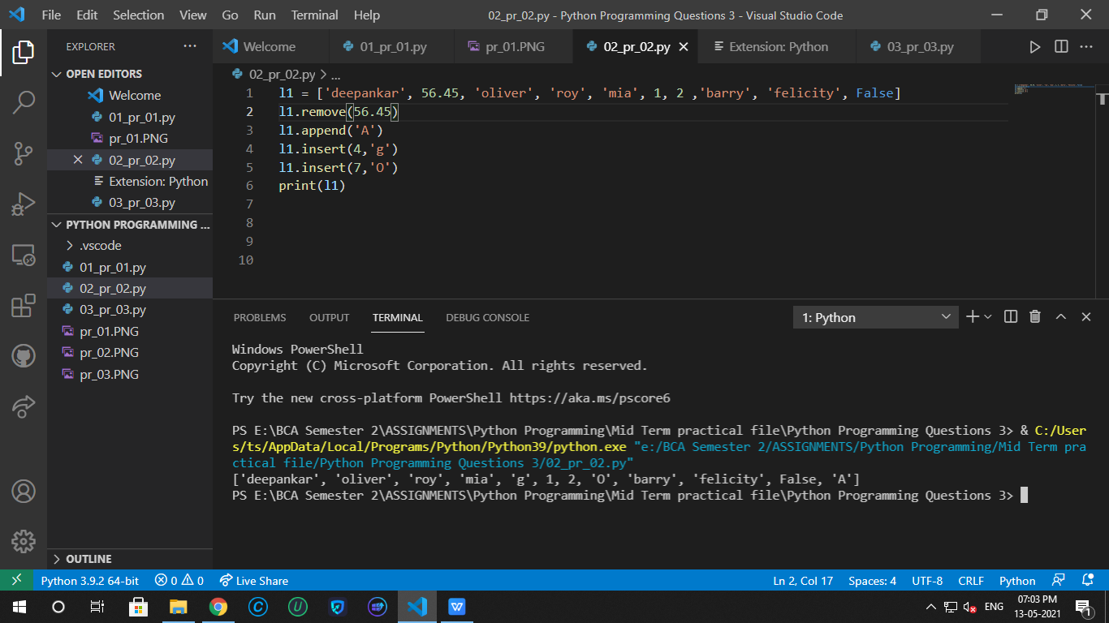

1. Consider any tuple containing integer, decimal and string values . Now delete all decimal values and then add three character values in it.

t1 = ('deepankar', 56.45, 'oliver', 'roy', 'mia', 1, 2 ,'barry', 'felicity', False)

t1 = list(t1)

t1.remove(56.45)

t1.append('A')

t1.insert(4,'g')

t1.insert(7,'O')

t1 = tuple(t1)

print(t1)

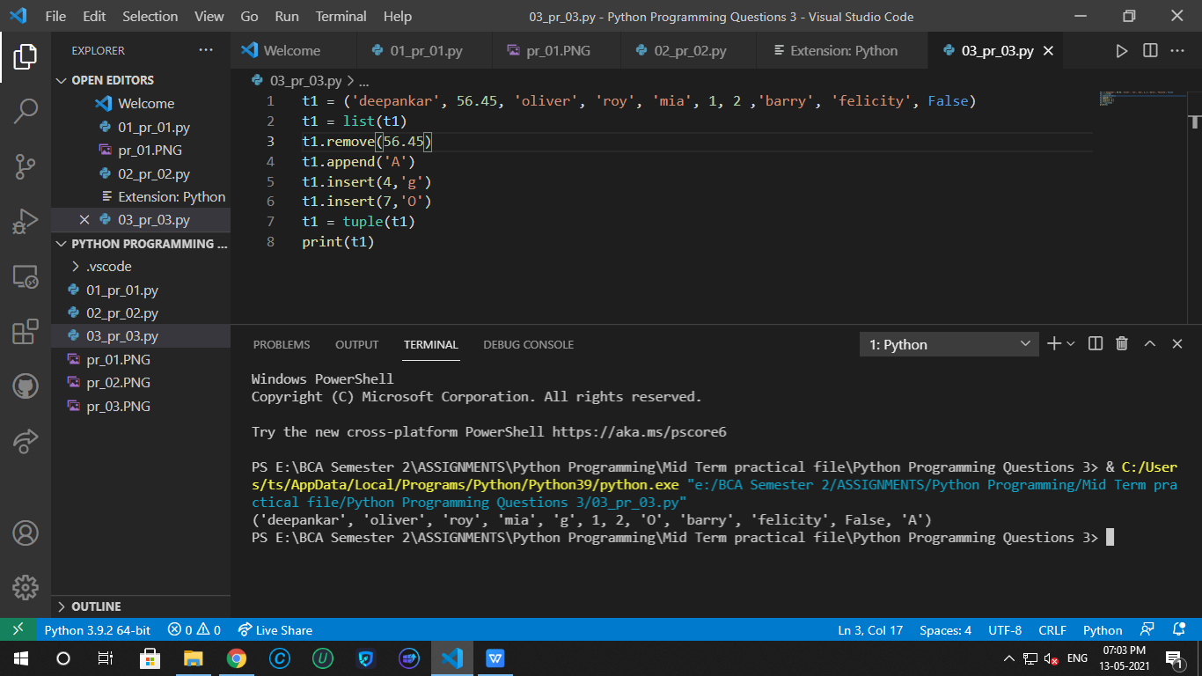

**Python Programming Questions 4**

1. Make a dictionary in which the keys are the numbers and the values are their cubes. Now first print the dictionary and then print the values of the dictionary.

my\_dict = { '1' : 1,

            '2' : 2\*\*3,

            '3' : 3\*\*3,

            '4' : 4\*\*3,

            '5' : 5\*\*3,

            }

print(my\_dict)

print(list(my\_dict.values()))

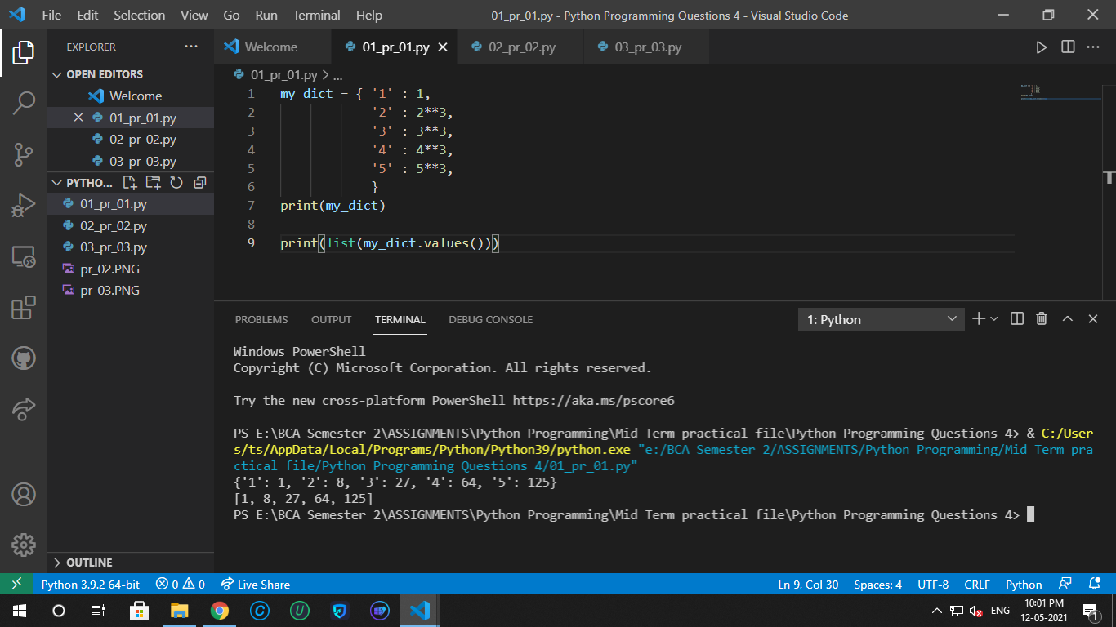

1. Consider an existing dictionary with some existing values. First empty the dictionary and then add some new key-value pairs to it.

my\_dict = { '1' : 1,

            '2' : 2\*\*3,

            '3' : 3\*\*3,

            '4' : 4\*\*3,

            '5' : 5\*\*3,

            }

my\_dict.clear()

print(my\_dict)

d1 = {

    'Deepankar':'Sharma',

    'Oliver':'Queen',

    'Dean':'Winchester'

}

my\_dict.update(d1)

print(my\_dict)

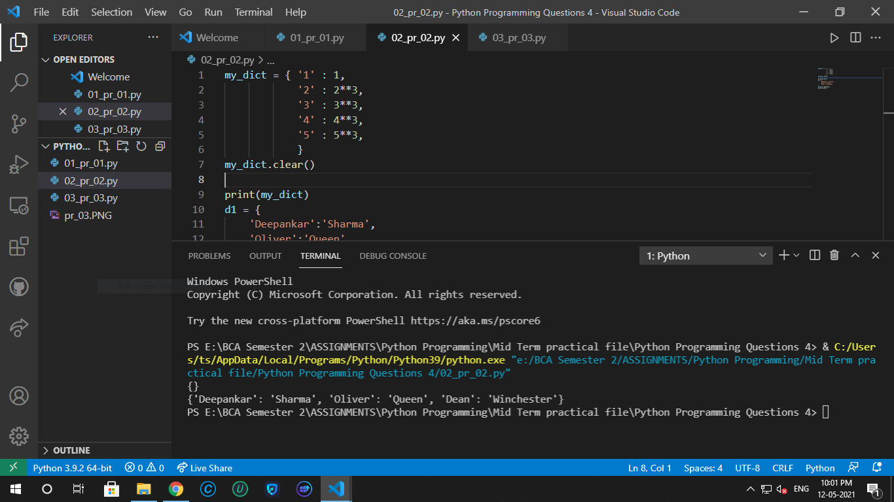

1. Write a python program to check any 5 values that is present in an existing dictionary or not.

my\_dict = { '1' : 1,

            '2' : 2\*\*3,

            '3' : 3\*\*3,

            '4' : 4\*\*3,

            '5' : 5\*\*3,

            '6' : 6\*\*3,

            '7' : 7\*\*3,

            '8' : 8\*\*3

            }

a = list(my\_dict.values())

print(1 in a)

print(6 in a)

print(125 in a)

print(455 in a)

print(64 in a)

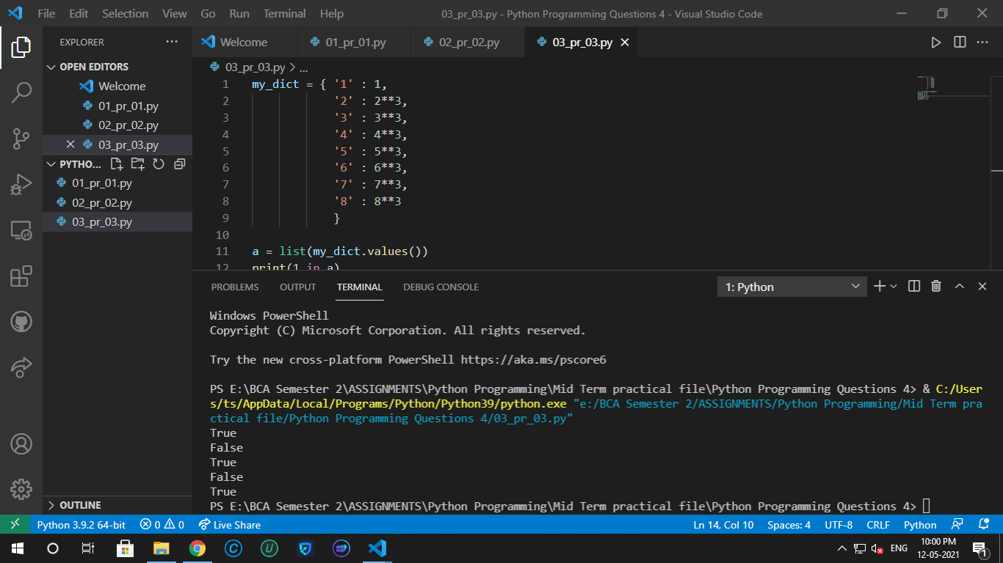

**Python Programming Questions 5**

1. Write a python program to check if the value entered by the user is a palindrome or not.

pal = input('Enter the value:   ')

if(pal==pal[::-1]):

      print("The value is a palindrome")

else:

      print("Not a palindrome")

**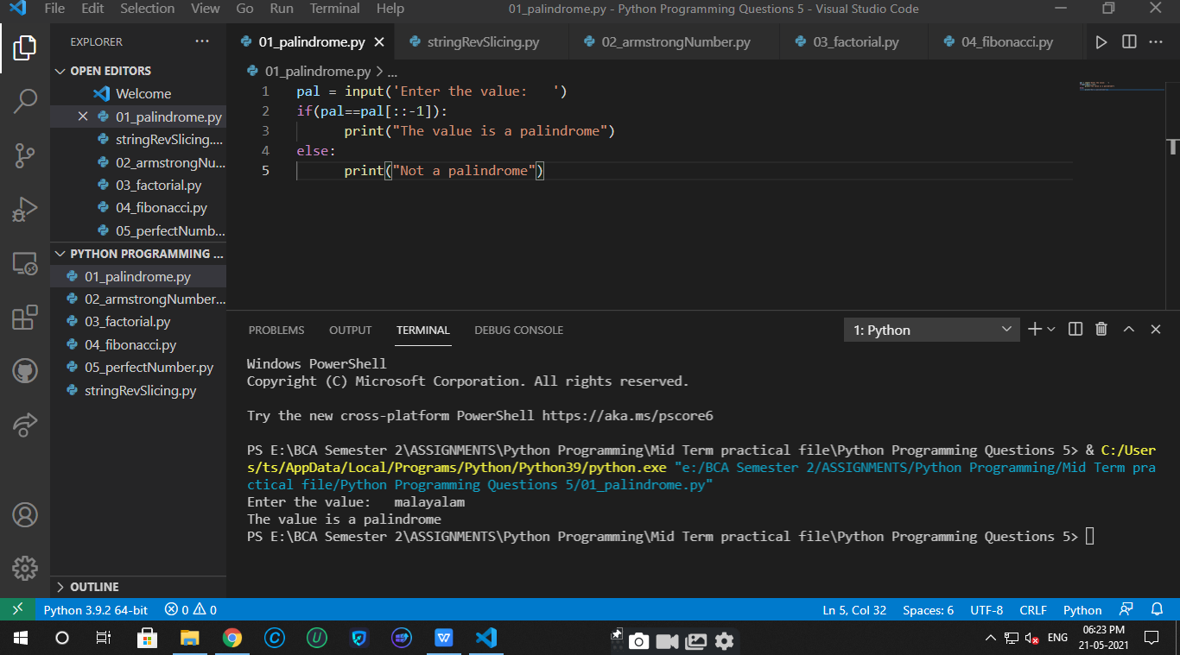**

1. Write a python program to check if the value entered by the user is a Armstrong number or not.

num = int(input('Enter the number:  '))

temp = num

sum = 0

while(temp>0):

    r = temp%10

    sum+=(r\*r\*r)

    temp//=10

if(num==sum):

    print('The number is a armstrong number')

else:

    print('The number is not a armstrong number')

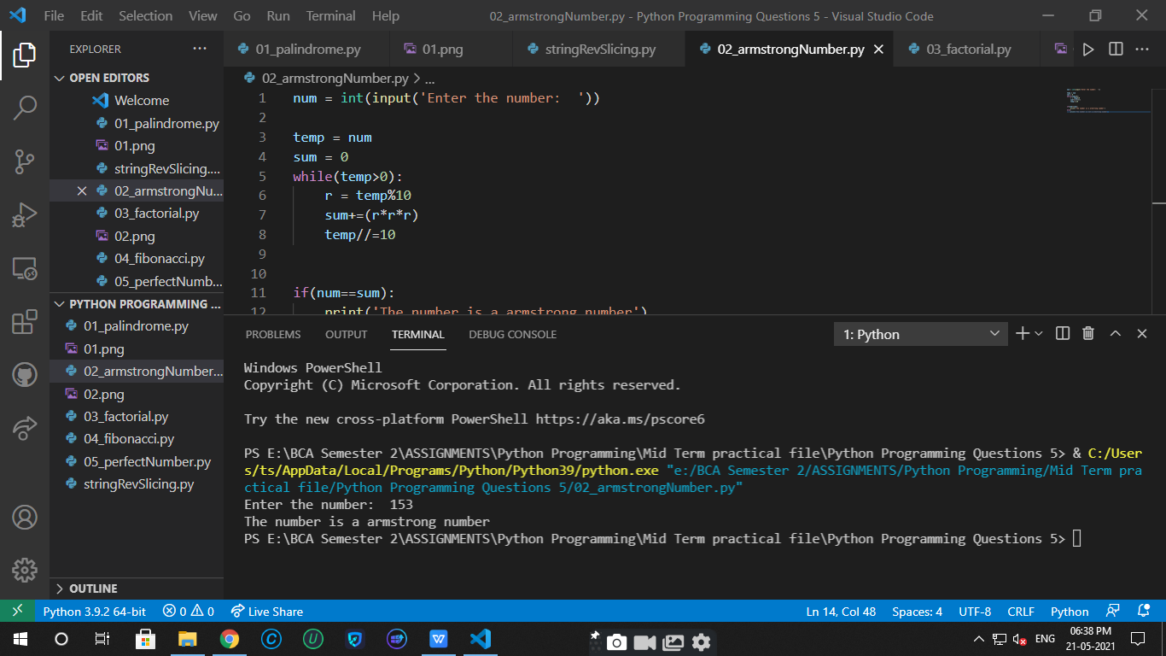

1. Consider a number given input by the user. Now find the factorial of the number.

def fact(num):

    if(num==0 or num==1):

        return 1

    return num\*fact(num-1)

num = int(input('Enter the number:  '))

print('The factorial of the number is ', fact(num))

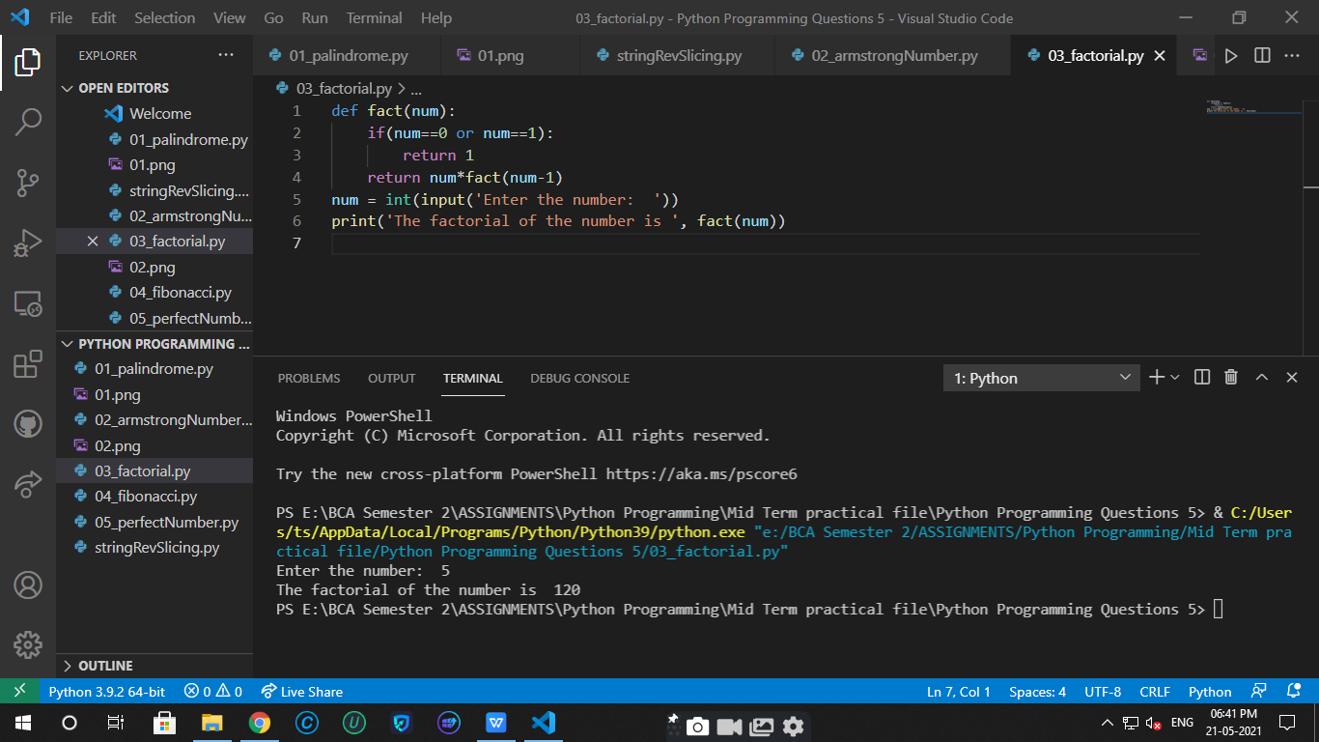

1. Write a python program to print the fibonacci sequence upto the range given by the user.

num = int(input('Enter the range for the series: '))

f1, f2 = 0, 1

for i in range(1,num+1):

    if i==1:

        print(f1)

    else:

        fn = f1+f2

        print(fn)

        f1 = f2

        f2 = fn

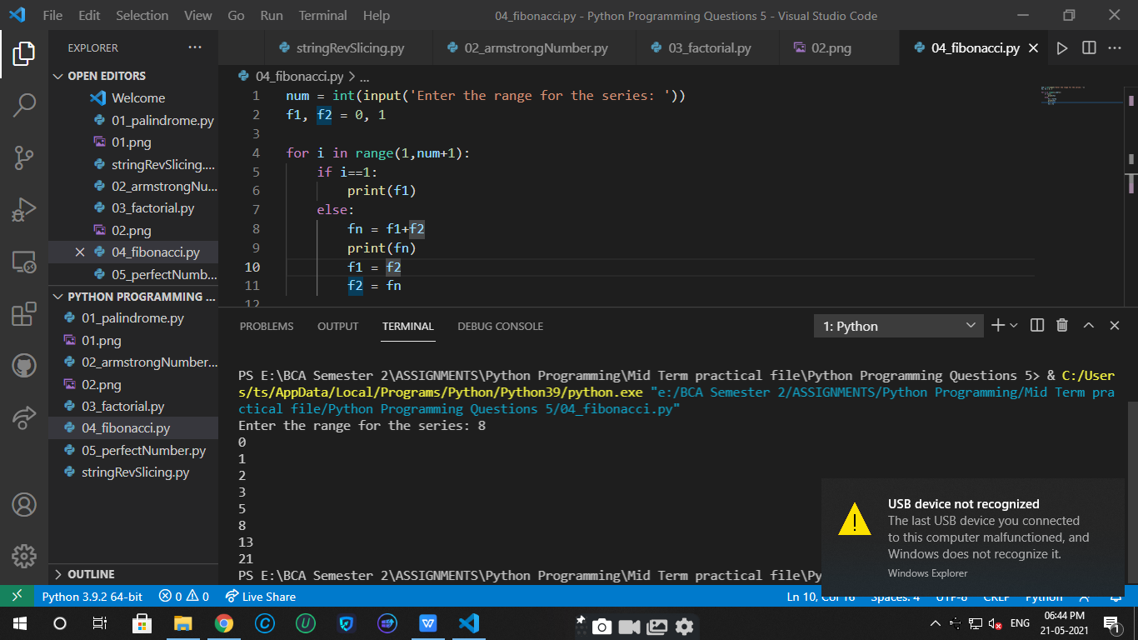

1. Write a python program to check whether the number entered by the user is a perfect number or not.

num = int(input('Enter the number: '))

sum = 0

for i in range(1,int(num/2)+1):

    if (num%i==0):

        sum+=i

if(num==sum):

    print('The number is perfect number.')

else:

    print('The number is not a perfect number.')

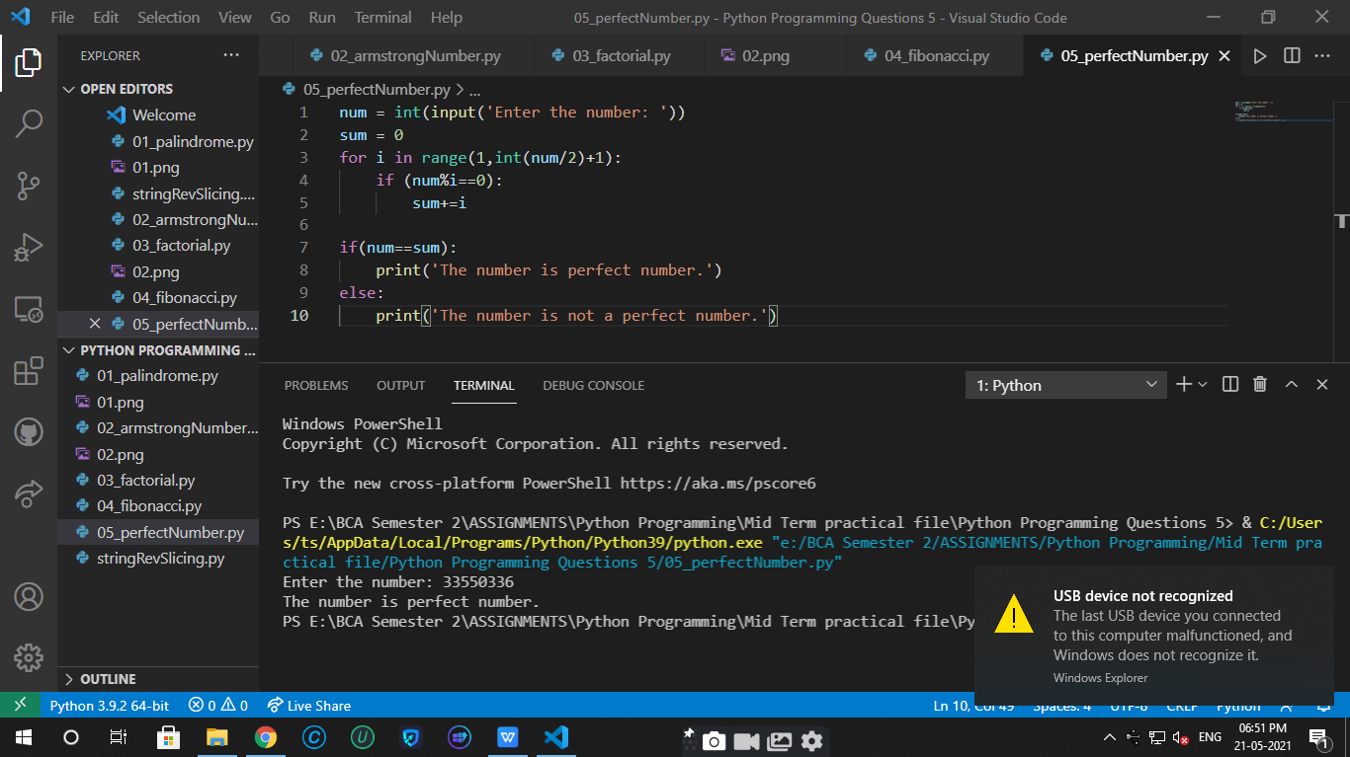

**Python Programming Questions 6**

1. Write a python program to remove duplicate values from a list.

l1 =['Ram', 'Hello', 2, 7, 'Ram', 1, 2, 2, '7']

print("The oringinal list is: ", l1)

l2=[]

for item in l1:

    if item not in l2:

        l2.append(item)

print('The list after removing the duplicates: ', l2)

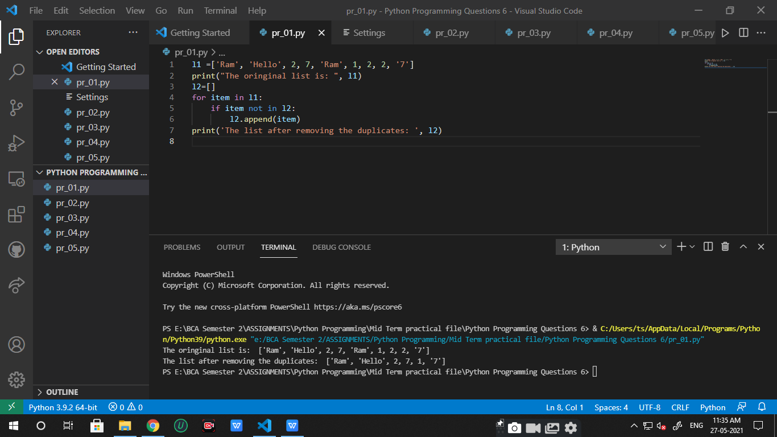

1. Write a python program to get a string from the user and check if it starts with ‘’is’’ or not. If not then add is with it.

str = input('Enter a string : ')

if str.startswith('is'):

    print('The string starts with "is"')

else:

    print('It does not start with "is"')

    str=(str+'is')

print(str)

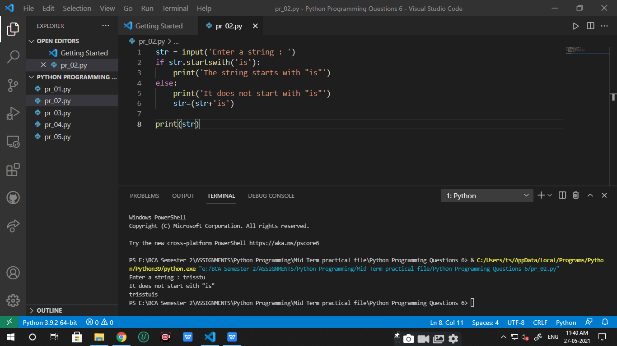

1. Write a python program to count the number of alphabets, digits and symbols in the string given by the user.

alpha=0

lett=0

symb=0

str = input('Enter some string:  ')

for i in str:

    if i.isalpha():

        alpha+=1

    elif i.isdigit():

        lett+=1

    else:

        symb+=1

print('Number of alphabets in the string is ', alpha)

print('Number of digits in the string is ', lett)

print('Number of symbols in the string is ', symb)

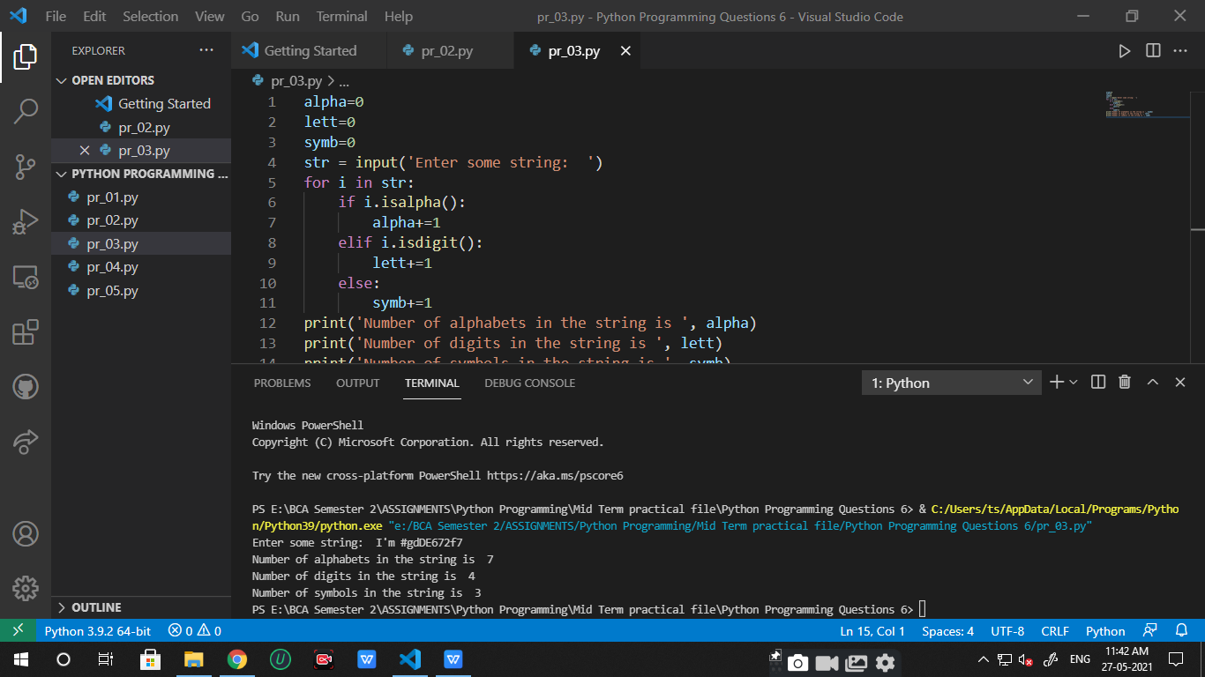

1. Take two dates of same month and same year from the user in the format dd/mm/yy. Now compare only the dates and calculate the number of days between the two dates and also print which date comes first.

d1 = input('Enter some date (dd/mm/yy): ')

d2 = input('Enter some date of same month and year (dd/mm/yy): ')

m1 = int(d1[:2])

m2 = int(d2[:2])

if m1>m2:

    print(f'The date {d2} comes first and the difference between two dates is of {m1-m2} days.')

else:

    print(f'The date {d1} comes first and the difference between two dates is of {m2-m1} days.')

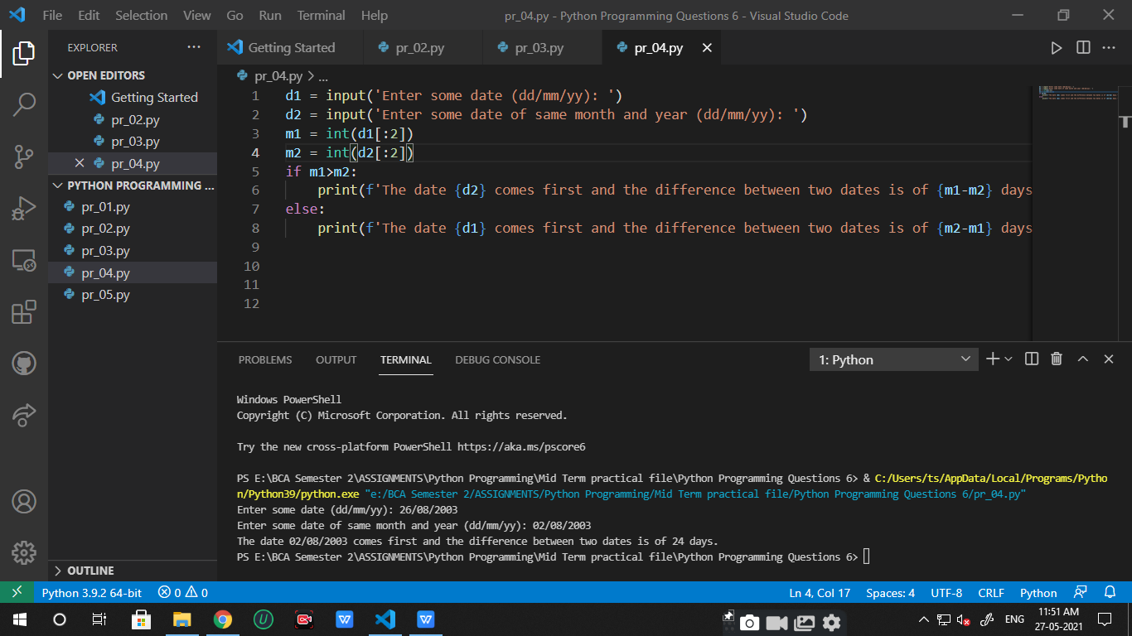

1. A student is not allowed to sit in exams ,if his/her attendance is less than 75%. Take following inputs from the user:

->number of classes held.

->number of classes attended.

Print the percentage of class attended and also tell if he/she will sit in the exams.

ch = int(input('Enter the number of classes held: '))

ca = int(input('Enter the number of classes the student attended: '))

perc = ca/ch

perc = perc\*100

if(perc<75):

    print(f'The student is not allowed to sit in exams as his percentage of class attended is {perc}.')

else:

print(f'The student is allowed to sit in exams as his percentage of class attended is {perc}.')

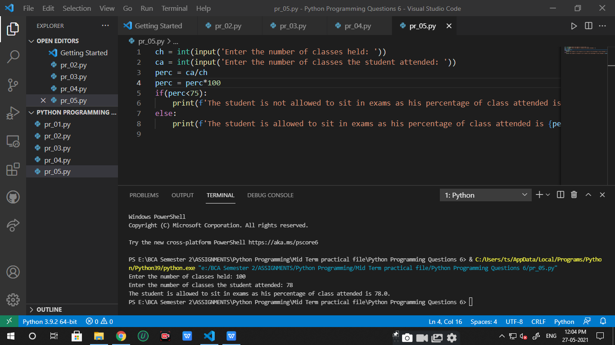

**Python Programming Questions 7**

1. Write a python program having a user defined function which will calculate the total number of vowels in a string given by the user.

def vowels(str):

    count =0

    for i in str:

        if i=='a' or i=='e' or i=='i' or i=='o' or i=='u':

            count+=1

    return count

str = input('Enter some string: ')

print('Number of vowels in the string is ', vowels(str))

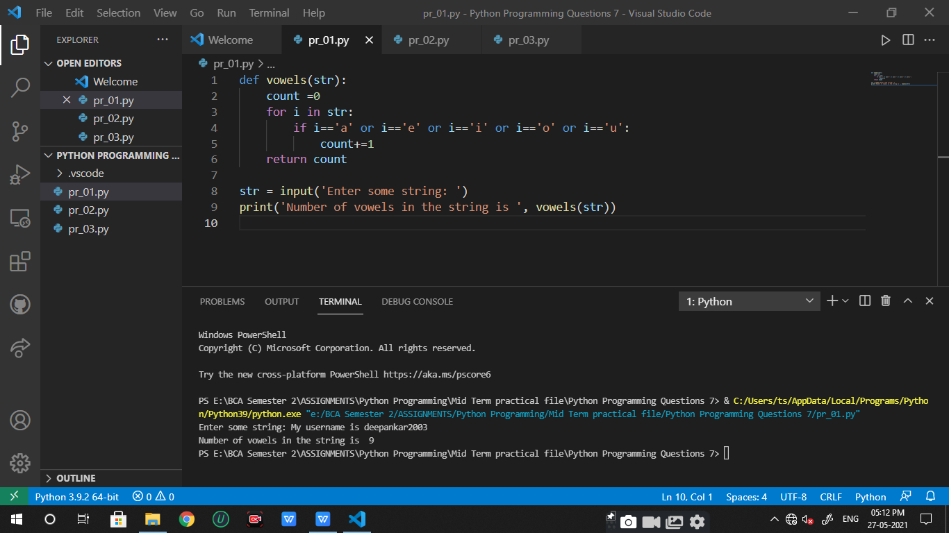

1. A shop will give discount of 10% if the cost of the purchased quantity is more then 1000 rupees. Now write a python on program having a user defined function which will first calculate whether the purchased quantity is more than 1000 rupees or not and then accordingly it will print the total cost for the user.

def totalCost(cost):

    if(cost>1000):

        cost = 0.9\*cost

    return cost

cost = int(input('Enter the cost of purchased quantity for the customer: '))

print('The total cost after calculating the discount: ', totalCost(cost))

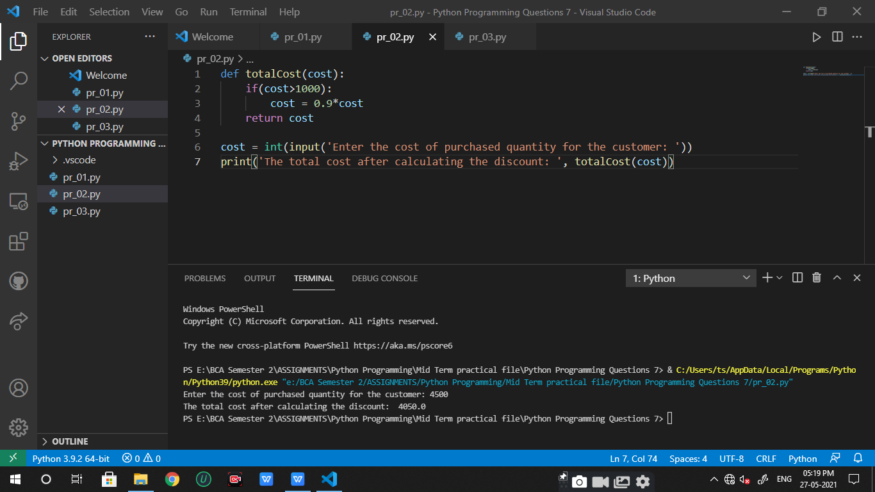

1. Suppose a company decided to give a bonus of 5% to their employee if his/her year of service in the company is more than 5 years. Now write a python program having a user defined function which will print the net bonus amount. Ask user to input the salary and the year of service.

def bonus(salary, yos):

    bonus=0

    if yos>5:

        bonus=0.05\*salary

    return bonus

salary = float(input('Enter the salary of the employee: '))

yos = int(input('Enter the year of service of the employee: '))

print(f'The net bonus of the employee is {bonus(salary,yos)} as his/her year of service is {yos} years')

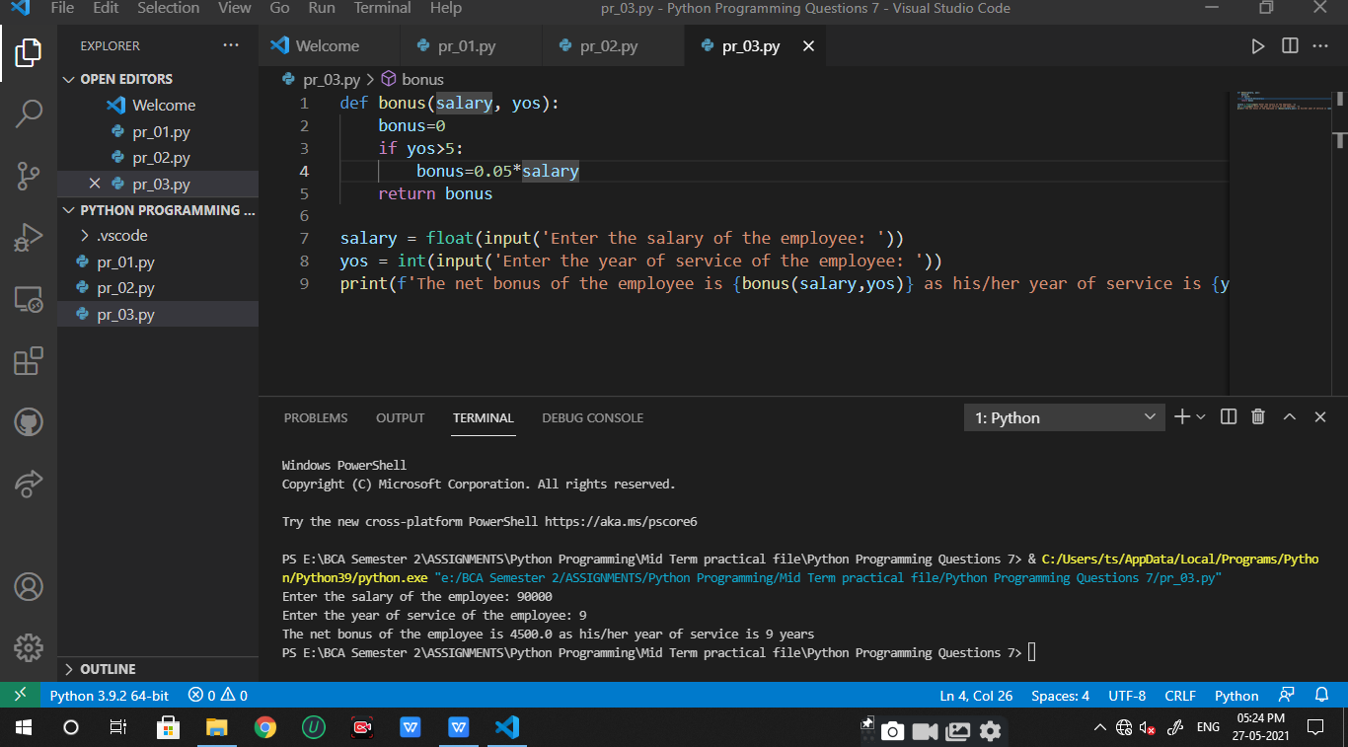

**Python Programming Questions 8**

1. Write a python class which takes values of length and breadth of a rectangle from the user and check if it is a square or not.

class Square:

    def \_\_init\_\_(self, length, breadth):

        self.length=length

        self.breadth= breadth

        if length==breadth:

            print('It is a Square !!')

        else:

            print('It is not a Square !!')

length = int(input('Enter the length: '))

breadth = int(input('Enter the breadth: '))

sq1 = Square(length, breadth)

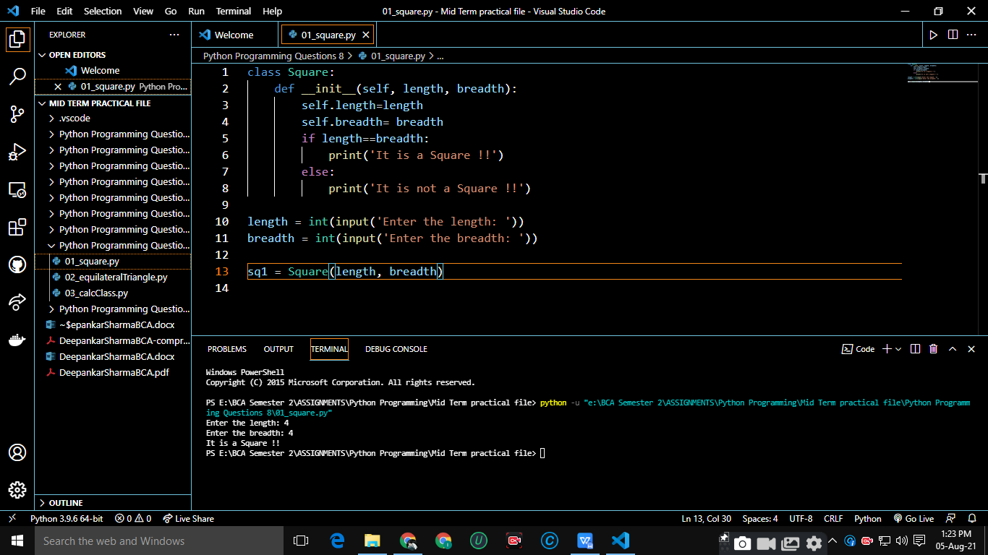

1. Write a python program which takes three sides of a triangle from the user and check if it is a equilateral triangle or not.

class EqTriangle:

    def \_\_init\_\_(self, x1, x2, x3):

        self.x1 = x1

        self.x2 = x2

        self.x3 = x3

        if x1 == x2 and x2==x3:

            print('It is a Equilateral Triangle !!')

        else:

            print('It is not a Equilateral Triangle !!')

x1 = int(input('Enter the side1: '))

x2 = int(input('Enter the side2: '))

x3 = int(input('Enter the side3: '))

sq1 = EqTriangle(x1, x2, x3)

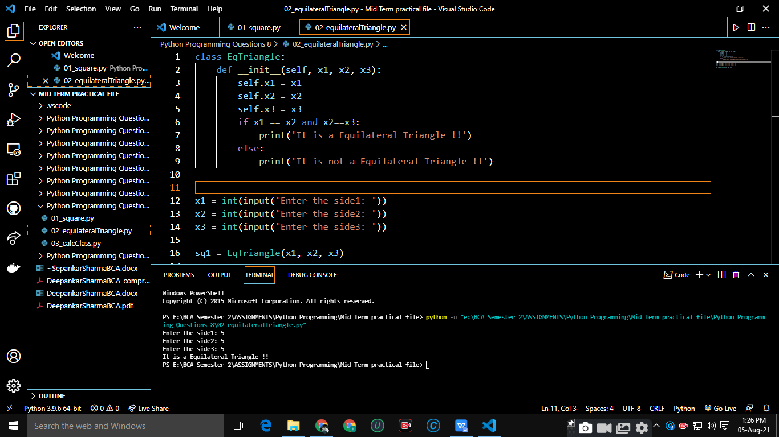

1. Write 4 python classes which can calculate Addition, Subtraction, Multiplication and Division. Take input from the user.

class Add:

    def \_\_init\_\_(self, a, b):

        print('The sum is :',a+b)

class Sub:

    def \_\_init\_\_(self, a, b):

        print('The difference is :', a-b)

class Mul:

    def \_\_init\_\_(self, a, b):

        print('The product is: ', a\*b)

class Div:

    def \_\_init\_\_(self, a, b):

        print('The quotient is:' , a//b)

a= int(input('Enter the first number: '))

b= int(input('Enter the second number: '))

x1=Add(a,b)

x1=Sub(a,b)

x1=Mul(a,b)

x1=Div(a,b)

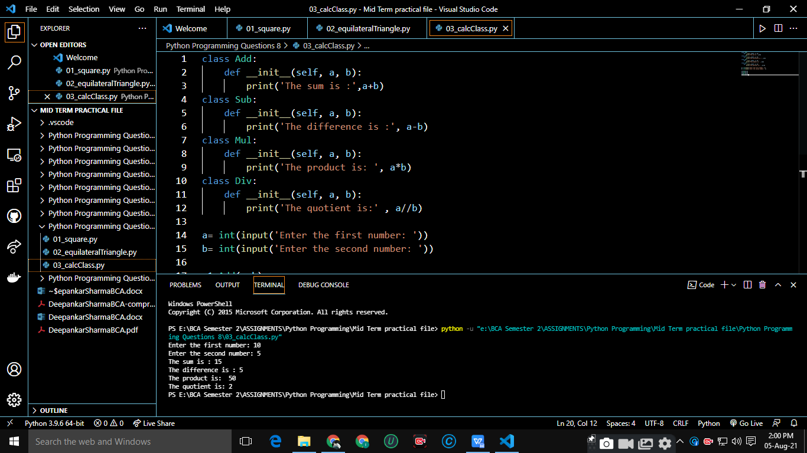

**Python Programming Questions 9**

1. Create a Python class having two functions to print even and odd numbers between 1 and 100.

class EveOdd:

    def \_\_init\_\_(self):

        self.even()

        self.odd()

    def even(self):

        for i in range(1, 101):

            if i%2==0:

                print(i, end=' ')

        print()

    def odd(self):

        for i in range(1, 101):

            if i%2!=0:

                print(i, end=' ')

        print()

x=EveOdd()

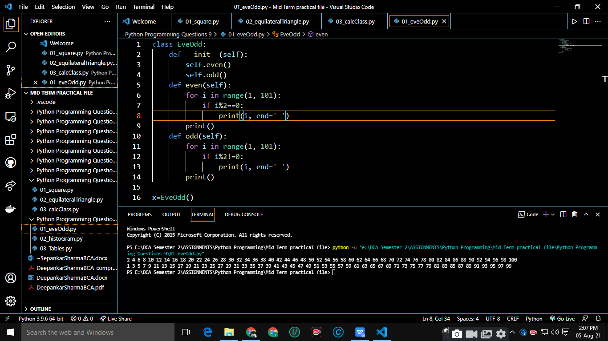

1. Write a Python program in which a class having function which will create a histogram of a given list of integers.

class HistPlot:

    def \_\_init\_\_(self, l):

        for i in l:

            print('\* '\*i)

l1=[]

x=int(input('Enter number of elements in the list: '))

for i in range(x):

    l1.append(int(input(f'Enter the element at {i}th index: ')))

x=HistPlot(l1)

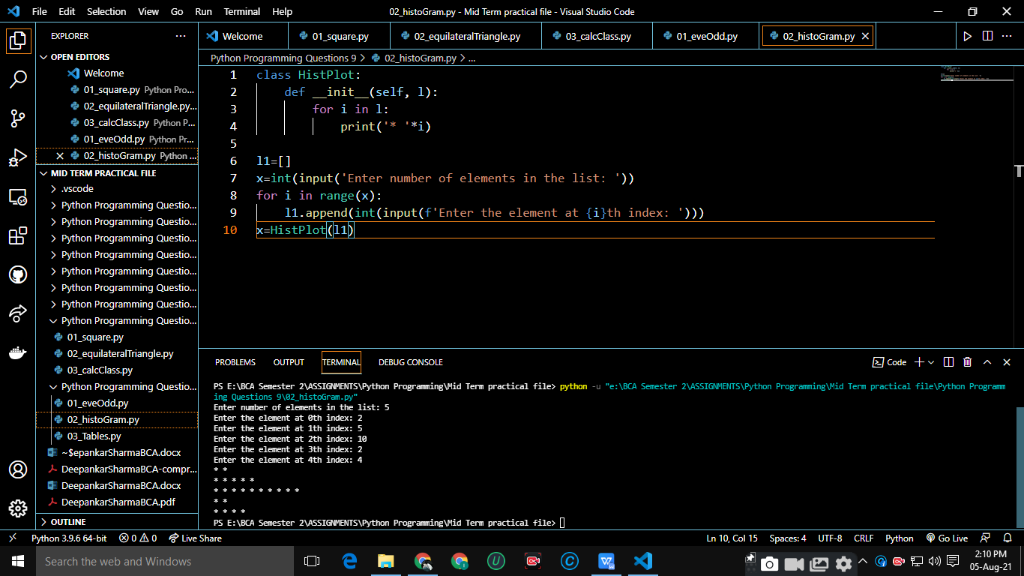

1. Write a Python program that have a class having a function that will print tables upto 5 of values from 2 to 5.

class Tables:

    def \_\_init\_\_(self):

        self.pnTable()

    def pnTable(self):

        for i in range(2,6):

            for j in range(1, 6):

                print(f'{i}\*{j} =  {i\*j}')

            print()

x=Tables()

